**SAMPLE TEMPLATE for a**

Santa Barbara County APCD Rule 331

**Fugitive Hydrocarbon Emissions**

**Inspection & Maintenance Plan**

for

Stationary Source: ABC Production, Inc. Zone A Oil; SSID No. 78910

Prepared for:

ABC Production, Inc.

1242 Brogard Ave, Goleta CA 93117

Prepared by:

3Party Inc.

Ventura CA 93004

Prepared Date: November 21, 2008

Plan Revision: 1.0

Appendix Updates: December 30, 2012

Table of Contents

1.0 Introduction 4

1.1 Plan Revisions 4

1.2 Facility Process Description 4

1.3 Precedence 5

2.0 Applicability 5

2.1 Facility Maps 5

3.0 Plan Revision History 6

4.0 Leak Detection and Repair (LDAR) Program 7

4.1 Definitions 7

4.2 Instrumentation 7

4.3 Calibration and Maintenance 7

4.4 Component Screening Procedures 7

4.5 Inspection Frequency and Methodology 8

4.6 Leak Repair 10

4.7 Leaking Component Identification 11

4.8 Major Gas Leak and Liquid Leak Limits 12

4.9 Reinspection 12

4.10 Best Available Control Technology (BACT) 12

5.0 Recordkeeping and Reporting 13

5.1 Component Leak Report 13

5.2 Component Summary Report 13

5.3 Work Request & Equipment Repair Tracking Report Including BACT 14

5.4 Retention of Records 14

6.0 Component Identification System 14

6.1 Major Components 15

6.2 Critical Components 15

6.3 Minor Components 15

6.4 De Minimis Components 15

6.5 Unsafe to Monitor Components 16

7.0 Exemptions 16

7.1 Entire Rule Exemptions 16

7.2 Partial Rule Exemptions 16

8.0 Calculating Fugitive Mass Emissions 16

9.0 Facility Specific Information 17

9.1 Facility: Lease BB 17

9.1.1 Permit/s Requiring FHC I&M Plan 17

9.1.2 P&ID/PFD 17

9.1.3 Component Inventory List 17

9.1.4 Component Summary Report 17

9.1.5 Component Leak Path Count Change Report 17

9.1.6 De Minimis Components List 17

9.1.7 Exempt Components List 17

9.1.8 Repair/BACT Summary 17

9.1.9 Fugitive Emissions Calculations – CLP Method 17

9.2 Facility: Lease CC 17

9.2.1 Permit/s Requiring FHC I&M Plan 17

9.2.2 P&ID/PFD 17

9.2.3 Component Inventory List 17

9.2.4 Component Summary Report 17

9.2.5 Component Count Change Report 17

9.2.6 De Minimis Components List 17

9.2.7 Exempt Components List 17

9.2.8 Repair/BACT Summary 17

9.2.9 Fugitive Emissions Calculations – CLP Method 17

9.2.10 Fugitive Emissions Calculations - CARB/KVB Method 17

10.0 Reference Documents 17

10.1 SBCAPCD Rule 331: Fugitive Emissions Inspection and Maintenance 17

10.2 EPA Method 21 – Determination of Volatile Organic Compound Leaks 17

10.3 SBCAPCD Rule 331 Best Available Control Technology Replacement Guidelines 17

10.4 SBCAPCD Policy and Procedure 6100.045.1994: Emission Reduction Allowance for Fugitive Hydrocarbon I&M Programs 17

10.5 SBCAPCD Policy and Procedure 6100.060.1996: Calculation of Fugitive Hydrocarbon Emissions at Oil and Gas Facilities by the CARB/KVB Method – Modified for the Revised ROC Definition 17

10.6 SBCAPCD Policy and Procedure 6100.061.1998: Determination of Fugitive Hydrocarbon Emissions at Oil and Gas Facilities Through the Use of Facility Component Counts - Modified for Revised ROC Definition 17

10.7 SBCAPCD Policy and Procedure 3100.II.V.1 Yr 2012: Rule 331 Enforcement Guidelines 17

10.8 Portable Analyzer Operator Manual for each Analyzer in Use 17

11.0 Forms 18

11.1 Component ID Tag 18

11.2 EPA Method 21 Precision Test Record 18

11.3 Leak Tag 18

11.4 Component Leak Report 18

11.5 Rule 331 Candidate BACT Replacement Reporting Form APCD-02A 18

11.6 Rule 331 Alternate BACT Replacement Proposal Form APCD-02B 18

11.7 Work Request & Equipment Repair Tracking Report including BACT 18

# 

# Introduction

This Fugitive Hydrocarbon Emissions Inspection and Maintenance Plan (FHC I&M Plan, or Plan) describes procedures used to:

1. Identify components subject to the Santa Barbara County Air Pollution

Control District (District) Rule 331 *Fugitive Emissions Inspection and Maintenance* (Rule);

1. Comply with the Rule requirements; and,
2. Report fugitive mass emissions.

Rule 331 requires facilities with components in liquid or gaseous hydrocarbon services at oil and gas facilities to submit a Fugitive Emissions Inspection and Maintenance Plan. A copy of the Rule is provided as Reference Document 10.1 of this Plan.

To calculate fugitive emissions, this Plan follows the guidelines of two District Policy and Procedure (P&P) documents:

* P&P 6100.060.1996 (*Calculation of Fugitive Hydrocarbon Emissions at Oil and Gas Facilities by the CARB/KVB Method - Modified for the Revised ROC Definition*). A copy of this P&P is provided as Reference Document 10.5 of this Plan.
* P&P 6100.061.1998 (*Determination of Fugitive Hydrocarbon Emissions at Oil and Gas Facilities Through the Use of Facility Component Counts – Modified for Revised ROC Definition*). This P&P guideline is often referred to as the “component leak path method” for calculating fugitive emissions. A copy of this P&P is provided as Reference Document 10.6 of this Plan.

## Plan Revisions

Plan revisions will be submitted as follows:

* An updated version of this Plan showing any change in the component inventory list or diagrams will be submitted to the District for review and approval within one calendar quarter (see Rule 331 Sec. I.1.) In general, these changes will be documented in updates to the facility specific information tables of Section 9 of the Plan.
* Any other changes to the Plan (e.g., Plan text or other tables or forms) will also be submitted on a calendar quarter basis.
* Changes to fugitive hydrocarbon mass emissions will be tabulated in revised Tables 9.1.5 and 9.1.9 (for component leak path method emissions calculations) and Tables 9.2.5 and 9.2.9 (for CARB/KVB method emissions calculations).

## Facility Process Description

ABC owns and operates Lease BB and Lease CC located in Santa Barbara County. Facility wells produce a combination of crude oil, water and natural gas from sub-surface formations. Process equipment then separates the gross combination into three phases. Please refer to the process description provided in District permit/s for these facilities. Sec. 9.1.2 and 9.2.2 of this Plan provide P&IDs and PFDs that clearly show processes and equipment (e.g., tanks, separators, wells etc.), as well as components detailed in Rule 331.G.1.b (major components, critical components, unsafe to monitor components etc.).

## Precedence

The requirements or limits that are more protective of air quality shall apply if any conflict arises between the requirement and limits of this Plan and District permits, Rules or Policies and Procedures associated with the equipment referenced herein.

# Applicability

This Plan applies to the following facilities:

|  |  |  |  |
| --- | --- | --- | --- |
| Facility Name | FID No. | Stationary Source Name | SSID No. |
| Lease BB | 12345 | ABC Production, Inc. Zone A Oil | 78910 |
| Lease CC | 12346 | ABC Production, Inc. Zone A Oil | 78910 |
| Additional leases, if any |  |  |  |

## Facility Maps

The maps below indicate the facility’s approximate location within the District’s jurisdiction.

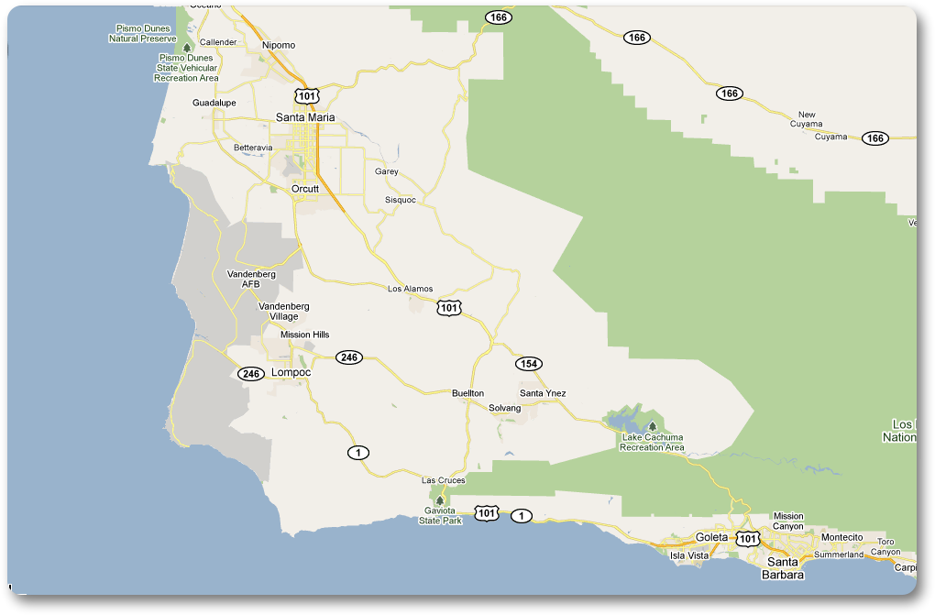

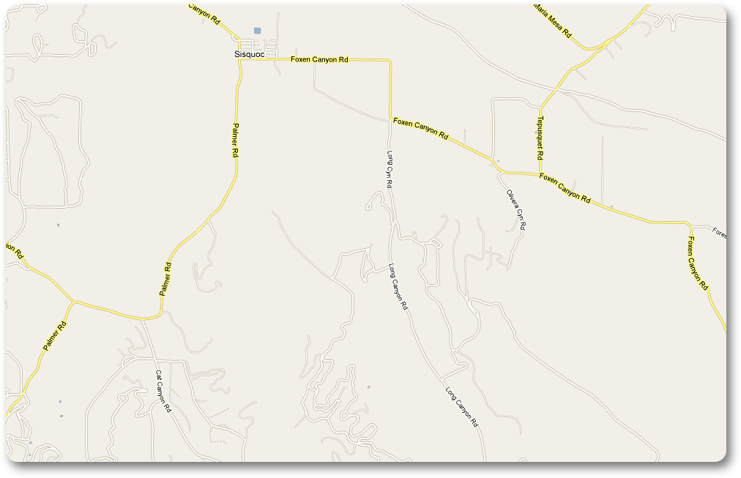

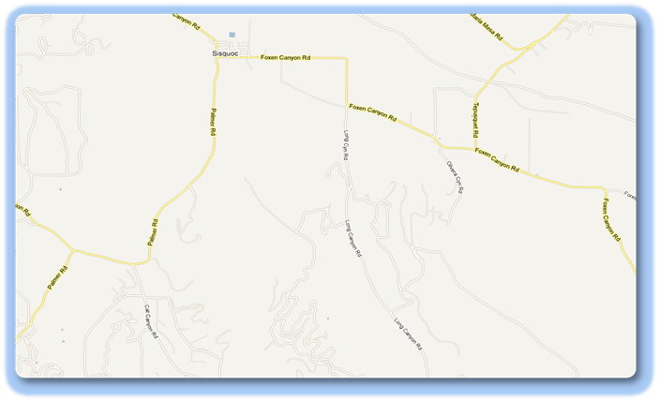

# Plan Revision History

The following table indicates changes to the Plan to track Plan history and evolution.

|  |  |  |
| --- | --- | --- |
| Plan Version | Date Modified | Comments |
| Revision 1.0 | November 21, 2008 | Original Plan |
| Add revisions as they occur |  |  |
|  |  |  |

# Leak Detection and Repair (LDAR) Program

ABC will use either 3Party Inc. or ABC’s employees in performing all routine inspections and reporting.

## Definitions

See Rule 331 and the other reference documents in Section 10.0 of this Plan for definitions of terms used in the Plan.

## Instrumentation

Inspections will be performed using a District-approved portable analyzer that satisfies the requirements of Rule 331 Sec. H.

The current TVA 1000B Operator’s Manual is included with this Plan; see Reference Document 10.8. Before using any other portable analyzer, ABC will obtain written District approval of the analyzer, and submit the appropriate Operator’s Manual.

## Calibration and Maintenance

Instruments are precision tested to determine if instrument calibration is required prior to an inspection as documented in EPA Method 21 – Determination of Volatile Organic Compound Leaks (see Reference Document 10.2 of this Plan).

Two known concentrations of methane gas (100 ppmv & 10,000 ppmv) are measured three times each. The instrument readings are recorded. The average difference of the actual concentration of methane vs. the instrument reading is calculated. Should the average difference be less than or equal to 10% the precision testing sheet will be completed and signed by the field technician, however, should the average difference be greater than 10% the instrument will be calibrated according to the manufacturer’s guidelines and the precision test will be repeated as necessary until the instrument is within the 10% range.

Pump adequacy, correct operation of electronics, and particle filters are evaluated daily, and throughout periods of operation. A log will be maintained showing maintenance and calibration records of the instrument, including dates and methods of calibration and/or repairs.

## Component Screening Procedures

Instrumentation and inspections of components will comply with the requirements of Rule 331. When conducting inspections, the probe inlet is placed at the surface of the component interface where leakage could occur, and moved along the interface periphery while observing the readout. If the source is a rotating shaft, the probe inlet is positioned within 1 centimeter of the shaft-seal interface for the survey.

Soap bubble screening may be used as an alternative screening procedure only where appropriate as described in Method 21 (see the Method’s Sec. 8.3.3 Alternative Screening Procedure). If soap bubble screening is used, and bubbles are observed, the instrument technique of Method 21 will be used within the same working day to determine if a leak exists.

## Inspection Frequency and Methodology

* Accessible components, except pump seals, compressor seals, pressure relief devices, flanged connections and threaded connections, will be inspected on a quarterly basis.
* Operating pump seals, compressor seals, and pressure relief devices will be inspected for leaks or indications of leaks by the facility operator at least once during every 8-hour operating period, except for components at oil or gas production fields and pipeline transfer stations where inspection shall be daily. If a leak is detected without Rule 331 approved instrumentation, a re-inspection using approved instrumentation will be performed within two calendar days. Additionally, all pressure relief devices (PRDs) that relieve to atmosphere will be inspected using approved instrumentation within three calendar days after every known pressure release.
* Flanges and threaded connections will be inspected immediately after assembly and on a quarterly basis thereafter.
* Inaccessible components will be inspected on an annual basis.
* Unsafe to monitor componentsidentified in the Exempt Components List (Form 9.1.7 or 9.2.7) will be inspected when it is determined safe to perform the inspections.
* Re-inspections for leaks that are minimized or repaired will be conducted within 30 calendar days of the minimization or repair action.

Components in parts of a facility that are not operating (i.e., for oil service components, drained of oil and isolated; for gas service components, drained and purged with inert gas and free of hydrocarbons, and isolated) are not subject to this Plan.

The following table summarizes the inspection frequency and methodology to be implemented at the facility. Except where otherwise noted, these are the minimum requirements set forth by Rule 331.

Rule 331.F Inspection Frequency and Methodology Table

|  |  |  |  |  |
| --- | --- | --- | --- | --- |
| Facility Type | Component Type | Inspection Frequency | Method | Rule 331.F. |
| All applicable | All accessible components, except threaded and flanged connections | Quarterly | Method 21 | 1 |
| All applicable | All accessible components except pump seals, compressor seals or PRDs | May become Annual if certain conditions are met | see Rule | 2 |
| All applicable | Inaccessible components | Annually | Method 21 | 3 |
| All applicable | Unsafe to Monitor components | When safe | Method 21 | 3 |
| All applicable | Flanged/Threaded Connections | Immediately after assembly | Method 21 | 4 |
| All applicable | Flanged/Threaded Connections | Annually | Method 21 | 4 |
| All applicable | Pressure Relief Devices | Quarterly | Method 21 | 5 |
| All applicable | Pressure Relief Devices | Within 3 calendar days after every pressure relief event | Method 21 | 5 |
| OGPPT | Pump Seals, Compressor Seals, PRDs | Daily | Visual | 7 |
| Non-OGPPT | Pump Seals, Compressor Seals, PRDs | Once per 8-hour operating period | Visual | 7 |
| All applicable | Pump Seals, Compressor Seals, PRDs | Within 2 days of leak detection | Method 21 | 7 |
| All applicable | Pump Seals, Compressor Seals, PRDs | Quarterly | Method 21 | 7 |
| All applicable | Each component subject to Rule | Reinspect within 30 days after leak minimization or leak repair | Method 21 | 6 |
| Table Notes: | | | | |
| * OGPPT means oil or gas production fields, and pipeline transfer stations. * Non-OGPPT means facilities other than OGPPT. Per Sec. A of Rule 331, this includes refineries, chemical plants, and oil and gas processing plants. | | | | |

According to Rule 331.F.2, upon approval by the Control Officer, the inspection frequency may be changed to “annually” for accessible components, except pump seals, compressor seals, and pressure relief devices, if all components at the facility have been successfully operated and maintained with no major gas or liquid leaks in excess of the leak thresholds specified in Table 1 of the Rule (see Section 4.8 of this Plan) for five consecutive quarters.

## Leak Repair

Leak repairs will follow the requirements of Rule 331. These requirements are generally discussed below, and summarized in the following Repair Requirements Table.

* When any gas leak from any component is detected, an initial attempt will be made to minimize or stop the leak immediately, but in no case more than one hour after the initial detection.
* Leaks which are not repaired by the end of the workday will be successfully repaired within the time limits established by the Rule, as described below.
  + All leaking critical components will be replaced with BACT components during the next process shutdown or within 12 months (whichever is sooner). Please refer to Section 4.10 (Best Available Control Technology) of this Plan for further details.
  + Major gas leaks from non-critical components will be successfully repaired within 5 calendar days of initial detection.
  + Minor gas leaks from non-critical components will be successfully repaired within 14 calendar days of initial detection.
  + Liquid leaks from non-critical components will be successfully repaired within 24 hours of initial detection.
  + All non-critical components with major gas leaks exceeding 50,000 ppmv (as methane) will be repaired within 1 calendar day (2 calendar days offshore; see Rule 331.E.1.f) of initial detection or removed from service until successfully repaired, unless prohibited by California Occupational Safety and Health Administration standards.
* A portable analyzer will be used to determine if the repair is successful.

Repair Requirements Table1

|  |  |  |  |  |  |  |  |
| --- | --- | --- | --- | --- | --- | --- | --- |
| Component Type | Type of Leak  (expressed as methane) | Minimized | Repaired | | | | BACT Replacement2 |
| One  Hour | 24 Hours | One calendar day if onshore; two if offshore | Five Calendar Days (non-critical components) | 14 Calendar Days (non-critical components) |
| Major | Minor Gas  (>1,000, <10,000 ppmv) | X |  |  |  | X |  |
| Major Gas  (≥10,000, ≤50,000 ppmv) | X |  |  | X |  | X3 |
| Major Gas  (>50,000 ppmv) | X |  | X |  |  | X3 |
| Liquid  (>3 Drops Per Minute) | X | X |  |  |  | X3 |
| Minor | Minor Gas  (>1,000, <10,000 ppmv) | X |  |  |  | X |  |
| Major Gas  (≥10,000, ≤50,000 ppmv) | X |  |  | X |  | X3 |
| Major Gas  (>50,000 ppmv) | X |  | X |  |  | X3 |
| Liquid  (>3 Drops Per Minute) | X | X |  |  |  | X3 |
| Critical | Minor Gas  (>1,000, <10,000 ppmv) | X |  |  |  |  | X |
| Major Gas  (≥10,000, ≤50,000 ppmv) | X |  |  |  |  | X |
| Major Gas  (>50,000 ppmv) | X |  |  |  |  | X |
| Liquid  (>3 Drops Per Minute) | X |  |  |  |  | X |
| Table Notes:   1. See Plan Sec. 4.10 and the BACT Replacement Guidelines (Reference Document 10.3) for further details about BACT. 2. BACT Replacement, if required, must occur during the next process shutdown or within 12 months (whichever is sooner). 3. Components which incur five repair actions for major gas or liquid leaks within a continuous twelve-month period. | | | | | | | |

## Leaking Component Identification

At the time of gaseous or liquid leak detection, all leaking components will be physically labeled with a bright green tag displaying the following information: component ID, date and time of initial leak detection, and severity of leak. Additionally, tags will show repair date and re-inspection information. Tags will be placed as near as possible to components that cannot feasibly be tagged. A sample of the leak tag is attached as Form 11.3 - Leak Tag.

As a supplement to leak tag placement, after the leaking component has been repaired, reinspected and found to be in a leak free condition, the Component Leak Report, described in the Recordkeeping and Reporting section of this Plan, will provide a record of the required leak information.

## Major Gas Leak and Liquid Leak Limits

If more major gas leaks or liquid leaks are found than allowed by the Rule 331 Table 1 below, the facility will be in violation of Rule 331. Failure to repair the leaks within the time allowed by the Rule would constitute a separate violation.

|  |  |  |
| --- | --- | --- |
| Table 1. Leak Thresholds | | |
|  | Maximum number of Allowable Leaks (Major Gas or Major Liquid) per Inspection Period | |
| **Component** | **Components Inspected** | |
|  | **200 or Less** | **Over 200** |
| Valves | 1 | 0.5% of number inspected |
| Pump Seals | 2 | 1% of number inspected |
| Compressor Seals | 1 | 1 |
| Pressure Relief Devices | 1 | 1 |
| Other Components | 1 | 1 |

## Reinspection

Following the repair or replacement of leaking components, the inspection protocol described above will be used to evaluate the results of the repair actions. The reinspection will take place as soon as practicable, but no later than 30 calendar days from the date on which the component was repaired or replaced. The verification conducted with a portable analyzer when the leak is repaired will satisfy the 30 day reinspection requirement.

## Best Available Control Technology (BACT)

Rule 331 has two specific provisions that require certain leaking components to be replaced with BACT components as determined by New Source Review, as follows:

Section D.4: Components or component parts that incur 5 repair actions for major gas or liquid leaks within a continuous twelve-month period.

Section E.1.b: All leaks from critical components.

BACT components are subject to lower LDAR thresholds than non-BACT components; see Appendix 5.1 of the BACT Replacement Guidelines included as Reference Document 10.3 of this Plan.

The procedures provided in Rule 331 Best Available Control Technology Replacement Guidelines, Revision 2.1 issued 3/17/99 (or the most current update) will be applied to any component requiring BACT replacement. The current or subsequent versions of the District BACT Replacement Guidelines document will be maintained as Reference Document 10.3 - BACT Replacement Guidelines. A summary of these guidelines follows:

1. The operator will determine if the leaking component can be replaced with one of the options available in the Guideline’s Appendix 5.1: Candidate BACT Replacement Technology and Performance Standards Table. If so, the operator will submit an approval request using Form APCD-02A (see Form 11.5 of this Plan for this Rule 331 Candidate BACT Replacement Reporting Form). If not, then an alternative BACT application will be submitted to the District for review, using Form APCD–02B (see Form 11.6 of this Plan for this Rule 331 Alternate BACT Replacement Proposal Form).
2. Approval requests for both BACT and Alternative BACT replacements will be made within 30 days of the initial leak detection.
3. Upon review, the District engineer will sign and return the completed form authorizing the request.
4. The operator or contractor will make the BACT replacement during the next process shutdown or within 12 months on initial leak detection, whichever is sooner.
5. The operator or contractor will then sign and date the “BACT Replacement Installed On” section of the form and return it to the District, after the BACT replacement has been made.
6. The Repair/BACT Summary (9.1.8 or 9.2.8) will then be modified within 30 days of the BACT component installation to reflect the BACT technology and performance standards associated with the new BACT component. A letter will be submitted to the District notifying of the update and will contain the appropriate District forms.
7. All BACT components will be permanently tagged in **bold type** to indicate the following:
   1. The fact that the component is a BACT component, and
   2. The BACT LDAR performance threshold to which the component is subject.

A log of all components awaiting BACT replacement and a log of all components that have been replaced with BACT will be maintained. Please see the Recordkeeping and Reporting section below for further details.

# Recordkeeping and Reporting

A recordkeeping system will be employed to contain the following reports and forms: Component Leak Report (Form 11.4),Component Summary Report (9.1.4 or 9.2.4),and theWork Request & Equipment Repair Tracking Report Including BACTform (Form 11.7). Identical copies of the reports will be maintained at three locations: at the ABC facility maintenance office, at the office of the third party contractor’s Project Manager, and with the LDAR field technician. An additional report, theRepair/BACT Summary report (9.1.8 or 9.2.8), will be used in conjunction with the Work Request & Equipment Repair Tracking Report including BACT (Form 11.7). The following are the protocols for the use of these reports and forms.

## Component Leak Report

The Component Leak Report is generated following the compilation of data from the field after each inspection sequence. It is the inspection log required by the Rule, and contains all the information required therein. All components that have been repaired with BACT shall be included in this report along with the new leak thresholds. A sample of the Component Leak Report is attached as Form 11.4.

## Component Summary Report

The Component Summary Report provides totals of all components by component type and process fluid service. A copy of this Component Summary Report (9.1.4 or 9.2.4) is attached.

## Work Request & Equipment Repair Tracking Report Including BACT

The Work Request & Equipment Repair Tracking Report Including BACT form will be completed in color-coded triplicate by the LDAR technician for each leak not successfully repaired at the end of each inspection workday. The Request for Repair will serve as notification to ABC personnel (white copy) and the 3Party Inc. Project Manager (pink copy) that action is required. The technician will retain the third copy of the form (yellow copy). A sample of the Work Request & Equipment Repair Tracking Report Including BACT is attached as Form 11.7. Upon successful repair of the leaking component, ABC personnel will complete the Facility Operator section of the form and transmit the completed form, via telefax or email, to 3Party Inc. The form will then be filed in the facility folder and retained as proof of compliance. Please note the Request for Repair form will be completed for both “Non-BACT” as well as “BACT” repairs.

If BACT replacement is required, as indicated on the Work Request & Equipment Repair Tracking Report Including BACT form, theRepair**/**BACT Summary report (9.1.8 or 9.2.8) will also be updated. The BACT Summary report provides detailed information to track all pending and completed BACT repairs insuring that BACT requirements are met within the required time frames.

All of the above reports will be maintained by the operator as required by Rule 331, and will be made available to the District upon request.

## Retention of Records

Inspection and repair records will be retained at the facility for the previous two years, at a minimum. Those records will be made available at the time of District inspection and will be provided to the Distirct upon request.

# Component Identification System

The Component Inventory tracks two things:

1. The component count for Rule 331, and
2. The component leak path count for calculating fugitive emissions.

The leak path count is different from the component count; one component may consist of several leak paths. Each line in the Inventory List represents one component for Rule 331. The component leak path count for each component is provided on each line.

Component and component leak path inventories will follow the District guidelines detailed in Policy and Procedure (P&P) No. 6100.061.1998 issued September 25, 1998 (or current updates; see Reference Document 10.6). The component leak path counting methodology detailed in that P&P’s Table 1(Leak Path Counting Methodology) will be used, and this Plan’s Component Inventory List (9.1.3 or 9.2.3) will provide the component type and the leak path count for each component.

Note that for facilities where no “as built” component count is available, this Plan uses the CARB/KVB method to calculate fugitive mass emissions. The inventory list shows Rule 331 component information, but does not count or show the component leak paths for these components. The information required in the table of Sec. 3.1 of P&P 6100.060.1996 (or updates thereto; see Reference Document 10.5) is provided in in Sections 9.2.3, 9.2.4 and 9.2.9 of this Plan.

P&IDs/PFDs. See Sec. 9.1.2 (for Lease BB) and 9.2.2 (for Lease CC) for P&IDs and PFDs that show the location of components detailed in Rule 331.G.1.b.

Exempt Leak Paths. Leak paths identified in Section I.3. of the referenced P&P as “exempt” will be shown in the Inventory List, but will not be included in leak path counts contributing to fugitive hydrocarbon emissions.

A Component Inventory list has been created to identify the components at the facility and is attached in electronic format. The entire facility is divided into broad areas; these areas are then divided into smaller sub-areas such as a vessel or tank. Sub-areas are further delineated by a description of the component’s location.

Each component is assigned a unique identification number in conjunction with the following component information: part name, size and District component category, permit number, service type (gas/vapor, light liquid or heavy liquid service), stream name, accessible or inaccessible, safe or unsafe to monitor, the major, critical, or de minimis status, and if it is ½” or less stainless steel tube fitting.

A component’s unique identification number is tracked by the placement of aluminum tags which are fixed with a stainless steel braided wire or silicon adhesive. These tags contain a unique tracking number that can be easily referenced to a hard copy print out or database. Components that do not have tags are referenced with a decimal number. A sample Component ID Tag is included as Form 11.1. Any information pertaining to a given component not printed directly on the tag is recorded in the inventory.

## Major Components

All major components are physically identified with Component ID Tags. Each tag contains a unique numeric barcode to clearly identify these components.

## Critical Components

Each critical component is itemized in the inventory with a unique ID number and monitored as part of the LDAR program.

## Minor Components

Minor components will be grouped together functionally with other tagged components. Most minor components will be referenced using a decimal numbering system, whereby a nearby whole tag number and a decimal number extension is assigned in a predetermined route based on functionality, or geography.

## De Minimis Components

De minimis components are new additions that have not been included in the permit due to the exemption allowed by District Rule 202.D.6. These components are inspected per Rule 331 and tracked in the component inventory.

## Unsafe to Monitor Components

Unsafe components will be inspected when it is safe to do so, such as during process shutdown or scheduled maintenance. These components are identified in the inventory and also shown in an Exempt Components List (9.1.7 or 9.2.7).

# Exemptions

Rule 331 includes certain exemptions from the entire rule (Section B.2) or from certain inspection requirements of the rule (see Section F). The Exempt Components List (9.1.7 or 9.2.7) is used to track component exemptions.

## Entire Rule Exemptions

The provisions of Rule 331 shall not apply to:

1. Components exclusively handling natural gas
2. Components buried below ground,
3. One-half inch and smaller stainless steel tube fittings which have been determined to be leak-free by the Control Officer based on an initial inspection in accordance with Section H.1 of Rule 331.

## Partial Rule Exemptions

The provisions of Sections F.1, F.2, F.3, and F.7 of Rule 331 shall not apply to:

1. Components exclusively in heavy liquid service,
2. Components, except components within gas processing plants, exclusively handling liquid and gaseous process fluids with an ROC concentration of 10 percent or less by weight, as determined according to test methods specified in Section H.2 of the Rule,
3. Components totally contained or enclosed such that there are no ROC emissions into the atmosphere,
4. Components incorporated in lines operating exclusively under negative pressures,
5. Any control valve actuation system, except those used in pressure relief valves and stuffing boxes, which uses gas pressure to open or close the valve and which releases gas to the atmosphere during this process, and for which the Control Officer has determined on a case-by-case basis that no alternate valve design can be feasibly used.

Please refer to the Exempt Components List (9.1.7 or 9.2.7) for a detailed list of any exemptions.

# Calculating Fugitive Mass Emissions

For facilities using the component leak path method, ROC emissions will be calculated per the guidelines of P&P 6100.061.1998. ABC will submit an emissions calculation table similar to that of this P&P’s Table 4: Example Fugitive Emission Calculations, with the appropriate quarterly, semi-annual or annual reports. The table/spreadsheets will be submitted in both hardcopy and as an electronic spreadsheet showing formulae. (Tables providing emission factors, emission control factors and performing the emissions calculations are included in Sec. 9.1.9 or 9.2.9 of this Plan.)

For facilities using the CARB/KVB method, ROC emissions will be calculated per the guidelines of P&P 9100.045. 1994. ABC will submit an emissions calculation table similar to that of this P&P’s Example Calculation (see p. 6-131),using the spreadsheets provided in Sec. 9.2.10 of this Plan, with the appropriate quarterly, semi-annual or annual reports. The table/spreadsheets will be submitted in both hardcopy and as an electronic spreadsheet showing formulae. (Tables providing emission factors, emission control factors and performing the emissions calculations are included in Sec. 9.2.10 of this Plan.)

# Facility Specific Information

## Facility: Lease BB

### Permit/s Requiring FHC I&M Plan

### P&ID/PFD

### Component Inventory List

### Component Summary Report

### Component Leak Path Count Change Report

### De Minimis Components List

### Exempt Components List

### Repair/BACT Summary

### Fugitive Emissions Calculations – CLP Method

## Facility: Lease CC

### Permit/s Requiring FHC I&M Plan

### P&ID/PFD

### Component Inventory List

### Component Summary Report

### Component Count Change Report

### De Minimis Components List

### Exempt Components List

### Repair/BACT Summary

### Fugitive Emissions Calculations – CLP Method

### Fugitive Emissions Calculations - CARB/KVB Method

# Reference Documents

## SBCAPCD Rule 331: Fugitive Emissions Inspection and Maintenance

## EPA Method 21 – Determination of Volatile Organic Compound Leaks

## SBCAPCD Rule 331 Best Available Control Technology Replacement Guidelines

## SBCAPCD Policy and Procedure 6100.045.1994: Emission Reduction Allowance for Fugitive Hydrocarbon I&M Programs

## SBCAPCD Policy and Procedure 6100.060.1996: Calculation of Fugitive Hydrocarbon Emissions at Oil and Gas Facilities by the CARB/KVB Method – Modified for the Revised ROC Definition

## SBCAPCD Policy and Procedure 6100.061.1998: Determination of Fugitive Hydrocarbon Emissions at Oil and Gas Facilities Through the Use of Facility Component Counts - Modified for Revised ROC Definition

## SBCAPCD Policy and Procedure 3100.II.V.1 Yr 2012: Rule 331 Enforcement Guidelines

## Portable Analyzer Operator Manual for each Analyzer in Use

# Forms

## Component ID Tag

## EPA Method 21 Precision Test Record

## Leak Tag

## Component Leak Report

## Rule 331 Candidate BACT Replacement Reporting Form APCD-02A

## Rule 331 Alternate BACT Replacement Proposal Form APCD-02B

## Work Request & Equipment Repair Tracking Report including BACT

9.1 Facility: Lease BB

9.1.1 Permit/s Requiring FHC I&M Plan

9.1.2 P&IDs/PFDs

Include in this section adequate P&IDs, PFDs, maps and/or drawings to allow straightforward location of and access to fugitive emissions components.

9.1.3 Component Inventory List

9.1.4 Component Summary Report

9.1.5 Component Leak Path Count Change Report

9.1.6 De Minimis Components List

9.1.7 Exempt Components List

9.1.8 Repair/BACT Summary

9.1.9 Fugitive Emissions Calculations – CLP Method

a) Fugitive ROC Emissions Calculations – CLP Method

b) Fugitive Emission Factors for Oil and Gas Facilities

c) Fugitive Hydrocarbon Control Factors

9.2 Facility: Lease CC

9.2.1 Permit/s Requiring FHC I&M Plan

9.2.2 P&IDs/PFDs

Include in this section adequate P&IDs, PFDs, maps and/or drawings to allow straightforward location of and access to fugitive emissions components.

9.2.3 Component Inventory List

9.2.4 Component Summary Report

9.2.5 Component Count Change Report

9.2.6 De Minimis Components List

9.2.7 Exempt Components List

9.2.8 Repair/BACT Summary

9.2.9 Fugitive Emissions Calculations – CLP Method

a) Fugitive ROC Emissions Calculations – CLP Method

b) Fugitive Emission Factors for Oil and Gas Facilities

c) Fugitive Hydrocarbon Control Factors

The emission calculations attached are for new equipment added to the facility after the original PTO was issued. They do not include emissions from component leak paths associated with the original permit.

9.2.10 Fugitive Emissions Calculations – CARB/KVB Method

The emissions calculations attached are for older equipment contained in the original PTO for this facility. The calculations do not include emissions from component leak paths associated with the original PTO.

10.0 Reference Documents

10.1 SBCAPCD Rule 331: Fugitive Emissions Inspection and Maintenance

10.2 EPA Method 21 – Determination of Volatile Organic Compound Leaks

10.3 SBCAPCD Rule 331 Best Available Control Technology Replacement Guidelines

10.4 SBCAPCD Policy and Procedure 6100.045.1994: Rule 331 Emission Reduction Allowance for Fugitive Hydrocarbon I&M Programs

Note: this P&P supersedes P&P 6100.033.1993.

10.5 SBCAPCD Policy and Procedure 6100.060.1996: Calculation of Fugitive Hydrocarbon Emissions at Oil and Gas Facilities by the CARB/KVB Method – Modified for the Revised ROC Definition

10.6 SBCAPCD Policy and Procedure 6100.061.1998: Determination of Fugitive Hydrocarbon Emissions at Oil and Gas Facilities Through the Use of Facility Component Counts - Modified for Revised ROC Definition

10.7 SBCAPCD Policy and Procedure 3100.II.V.1 Yr 2012: Rule 331 Enforcement Guidelines

10.8 Portable Analyzer Operator Manual for each Analyzer in Use

11.0 Forms

11.1 Component ID Tag

11.2 EPA Method 21 - Precision Test Record

11.3 Leak Tag

11.4 Component Leak Report

11.5 Rule 331 Candidate BACT Replacement Reporting Form APCD-02A

This form is included as Appendix 5.2 in the Rule 331 BACT Guidelines in Sec. 10.3 of this Plan.

11.6 Rule 331 Alternate BACT Replacement Proposal Form APCD-02B

This form is included as Appendix 5.3 in the Rule 331 BACT Guidelines in Sec. 10.3 of this Plan.

11.7 Work Request & Equipment Repair Tracking Report including BACT